*Table of Contents*

Introduction …………………….……………………………...…………………………..………. 3

…………………….……………………………………………………………………………..

Question I. Interpreting the coefficient and statistical significance of a

Regression: Regression C………………………………………………………….…………. 3 - 4

…………………….……………………………………………………………………………..

Question II. Exploring the Relationship between IQ, College_graduate & Earnings

using the Omitted Variable Formula ..….……………………………………………………. 4 - 7

…………………….……………………………………………………………………………..

Question III. Self-Selection Bias in the National Longitudinal Survey of Youth…………. 7 - 8

…………………….……………………………………………………………………………..

Question IV. Choosing Regression D.……………………………………………………… 8 - 9

…………………….……………………………………………………………………………..

Bonus…………………….……………………………………………………………………. 9 - 10

…………………….……………………………………………………………………………..

Question V. In response to the New York Times quote…………………………………… 10 - 11

…………………….……………………………………………………………………………..

Appendix …………………….…………………………………………………………………. 12 - 18

…………………….……………………………………………………………………………..

**Introduction**

The goal of this report is to determine whether graduating from college is predictive of higher earnings. We found that college is, in fact, a good investment because of its positive correlation to predicted earnings as well as cognitive ability. In other words, a college degree is a good indicator of a person’s predicted earnings, as we were able to show higher earnings, on average, for graduates than non-graduates even when controlling for other relevant variables. The benefits of college attendance are not limited, however, to earnings: we were able to show that getting a college degree is positively correlated to an increase in cognitive ability as measured by IQ.

Throughout our report, we used data analysis and statistical techniques in order to test whether college is worth its cost. In Part A, we used descriptive statistics and graphical methods to explore the earnings gap in relation to college attendance as well as other variables such as IQ, geographical location, and gender. In this second part of the report, we used regression analysis to formally test the relationships we had observed and were able to use different full models to isolate the effect of different variables to better understand the earnings gap and how it relates to the value of a college degree. As aforementioned, we were able to conclude that college attendance is a good investment because it has a significant positive effect on a person’s predicted earnings and cognitive ability.

QUESTIONS

1. ***Interpreting the coefficient and statistical significance of a Regression: Regression C***

In total, our Part B includes four different regressions we model, each with different variables that allowed us to isolate and interpret each variable’s effect on earnings. The four regressions, A-D, can be found in our Regression Table in the Appendix as well as throughout the report, where we use the models to test different relationships among the variables. For our third regression, we regressed earnings on college graduation, gender, rural residence, and IQ. This yielded Regression C, where:

**Predicted Earnings = -26,296 + 783*IQ -2,715*Rural - 28,475*Female + 33,826*College Graduate**

This regression predicts average annual earnings based on their IQ, if they live in a rural or non rural area, their gender, and their college graduate status. The intercept of the equation is -26,296. The intercept in this equation isn’t very useful since no one has an IQ of zero. If we interpret it literally, the intercept tells us that if someone has an IQ of zero, they live in a nonrural area, they’re male, and a non college graduate, their income is $26,296. This is impossible because you can’t have a negative income.

Holding all other variables constant, predicted earnings will increase by $783 for every point increase in IQ, those who live in a rural area earn $2,715 less on average than those who do not, women earn an average of $28,475 less than men, and college graduates earn $33,826 more on average than non-graduates.

All of these variables are statistically significant at a 95% confidence level, with t stats greater than the absolute value of 3, except for the Rural variable. However, the t stat is -1.585, which would be considered to be relatively close to significant at a 95% confidence interval, and extremely close to significant at a 90% confidence interval.

***II. Exploring the Relationship between IQ, College_graduate & Earnings using the Omitted Variable Formula***

The relationship between college attendance, cognitive ability, and earnings is positive. Breaking it down, we’ve concluded that there is a positive correlation between:

**(1)** College attendance and earnings,

**(2)** IQ and earnings, and

**(3)** College attendance and cognitive ability.

In order to reach this conclusion, we analyzed limited and full regression models and then applied the theory of omitted variable bias to examine relationships between the aforementioned variables.

Using our full model (Regression B), where we regressed earnings based on college attendance, gender dummy, rural dummy and IQ, we were able to reach our first two conclusions. Conclusion **(1)** isthat there’s a positive correlation betweencollege attendance (“CollegeGraduate”) and earnings (Y), and conclusion **(2)** saysthat there’s a positive correlation betweencognitive ability (“IQ”) and earnings.

**Regression B:**

**Predicted Earnings = -26,296 + 783*IQ -2,715*Rural - 28,475*Female + 33,826*CollegeGraduate**

Y = b0+ b1X1 + b2X2

In this full model, Y (earnings) is a function of various explanatory variables, including X1 (CollegeGraduate) and X2 (IQ). When interpreting the regression, we can conclude that college graduates earn on average $33,826 more than non-graduates, controlling for all other explanatory X-variables. Given that being a college graduate (when “CollegeGraduate” dummy=1) increases predicted earnings by $33,826 on average, it is evident that there is a positive relationship between college attendance and earnings, and that our conclusion **(1)** holds true. The same analysis can be applied to IQ: since b2 (the coefficient of IQ) is positive, we can see that for every extra IQ-point scored earnings increase by $782 on average (holding all other variables constant).

Our third conclusion (3) about the relationship between IQ and college attendance required a deeper analysis. For this, we applied the theory of omitted variable bias, comparing our limited model (Regression A) to our full model (Regression B).

|  |  |
| --- | --- |
| Regression A (Limited model) | Regression B (Full model) |
| **Y= 32,006 + 47,573*CollegeGraduate**  Y = c0 + c1*X1 | **Y= -26,296 + 783*IQ -2,715*Rural - 28,475*Female + 33,826*CollegeGraduate**  Y = b0+ b1X1 + b2X2 |

In analyzing the limited model, we are able to see that it omits variables that could have a relevant effect on Y, such as IQ. We know that IQ is a relevant variable that affects Y because of our findings in Part A. In Project A, we found that average IQ was higher (113) among college graduates, who scored on average more than the population (average IQ =100) and more than their non-graduate peers (average IQ = 95). Intuitively, it makes sense that college graduates have higher IQ, as an extra four years of education should have a positive effect on cognitive ability. It also makes sense that IQ affects our Y, earnings. Therefore, our simple model (Regression A) is biased because it’s omitting the background effect of “CollegeGraduate” on IQ and omitting the effect of IQ on Y (earnings).

Graphically, we’re saying that:

While regression A shows us that *X1 (College Graduate Dummy) has a c1 effect on Y (Earnings),*

*Image 1*

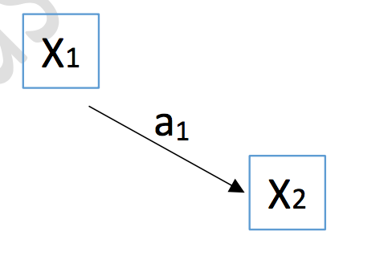

It fails to account for the background relationship between *X1 (CollegeGraduate) and X2 (IQ):* X1 has an effect, (a1), on X2.

*Image 2*

This is why the first regression is biased: it omits an important variable (IQ) that affects Y, and it omits the correlation between the explanatory variables “college attendance” and “IQ.” To find out the direction of the bias, we use omitted-variable-bias formula which says that

**c1 = b1***(the direct effect of X1 on y)***+ a1b2** *(known as the bias term)*

Therefore, by plugging the values we know (from Regressions A and B) in we get that c1 = b1+ a1b2  **→** 47,573 = 33,826 + a1b2 .A1*b2 is known as the bias term, and is specifically responsible for calculating the direction of the bias. In our case, since c1> b1 (c1=47,573 > b1=33,826), we can see that the bias A1*b2 must be positive. Further solving for a1 (which, as shown in *Image 2* is the relationship between X1 and X2) yields that a1>0. This proves that there's a positive correlation (a1>0) between “CollegeGraduate” and “IQ.” Said differently, we were able to conclude **(3)**, that X1 (college graduate) has a positive effect on X2 (IQ). We can say that going to college has a positive effect on IQ.

To summarize our findings graphically:

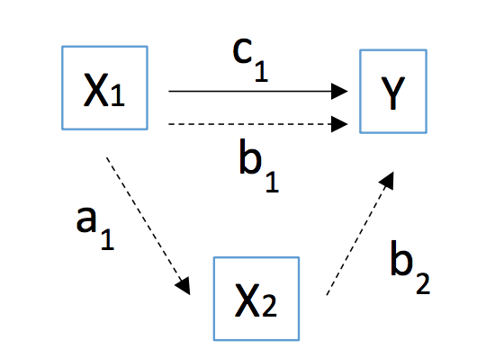

*Image 3*

1. **X1 has a positive effect, b1(=$33,826) on Y.** Earnings increase by $33,826 on average if person is a college graduate (holding other X’s constant)
2. **X2 has a positive effect b2 (=$782) on Y.** Earnings increase by $728 on average for every extra point of IQ scored (holding other X’s constant). Recall also that b2 is also in the “bias term” and since a1>0 and a1b2>0, then b2 must be positive which further confirms that IQ has a positive effect on Y (earnings).
3. **X1 has a positive effect, a1 on X2.** Being a college graduate has a positive effect on IQ scores. A1 = 17.6, which means college attendance increases IQ scores by 17.6 points on average (holding other X’s constant).

As we mentioned, these findings tell us that college attendance, IQ, and earnings are all positively correlated. Therefore, going to college correlates to higher earnings, on average, compared to those who did not attend. Similarly, every extra IQ-point scored increases earnings on average, holding other variables like gender constant. Both of these conclusions are intuitive and easy to make sense of given what we have been told about the value of higher education and intelligence. The most interesting conclusion was that college attendance is positively correlated to IQ, meaning attending college increases IQ. This speaks to the value of higher education as it is yet another benefit for those that go to college. For some, this might be a factor more important than earnings when debating the worth of their college attendance.

***III. Self-Selection Bias in the National Longitudinal Survey of Youth***

Self-selection bias is when participants in a dataset choose their group or opt in to a survey. Because the data in this project, from the National Longitudinal Survey of Youth, is compiled using a survey, it contains an element of selection bias. Even though the survey states that the sample is random and representative of the U.S. population, it is important to keep in mind that the participants in the survey chose to subject themselves to lots of questions, research, and multiple IQ tests. This type of research could attract a certain type of person which could bias the study. For example, those who felt that their college educations reflected higher earnings might have been more willing to participate to try and prove that their investment in college was worthwhile. On the other hand, it's possible that people were more likely to participate in the study if they weren’t working full-time jobs and had extra time on their hands, which would bias the study as well since they might have lower annual earnings on average. Some individuals might feel hesitant to disclose their income if it is low, and on the other hand others might want to demonstrate their high income. This might have influenced who participated in the survey and consequently skewed the results. Additionally, the survey does not note if any of the categories are self-reported, which could add another level of bias if people were untruthful or had different standards about the meaning of certain variables.

***IV. Choosing Regression D***

**Predicted Earnings = -33,885 + 707*IQ - 9,042*Northeast - 26,402*Female + 31,752*CollegeGraduate + 7,291*MotherWentToCollege + 301*Hours**

For the last regression, we first created dummy variables for regions and ran a regression with all of the numerical and dummy variables, which we termed the “Kitchen Sink” regression. We observed the t-stats of all the variables in the output and thought critically about those we thought could be important in predicting future earnings. Eventually, we decided to use college graduate status, whether or not the participant’s mother went to college, hours, IQ, gender and whether the participant was in the Northeast. These particular variables had t-stats higher than two, with many of them exceeding ten. The changes we made in Regression D resulted in a higher adjusted r-squared value, 0.025 larger than Regression C. This indicates that Regression D fits the data better than the previous regressions.

We were especially interested in how having a mother who went to college might affect a participant’s future earnings, because we hypothesized that those participants might have had more access to resources and to attend college. Before including this variable, we observed that a larger percentage of participants who graduated college also had a mother who attended college, but that overall, only twenty percent of the participants reported that their mothers attended college. Our findings in Regression D showed that having a mother who went college increased annual earnings by $7,291 on average.

Our team also chose to include the Northeast indicator variable, which shows the difference in annual earnings on average for those located in the Northeast as opposed to three other regions. This was the only region that had statistical significance in the Kitchen Sink regression. As noted in Part A, we thought the difference in earnings in the Northeast region could stem from the amount of prestigious colleges. However, it’s also possible the variation represented by this variable shows the widely differing pay scale in cities and large amounts of corporate jobs that might not be present in rural areas. This suggests that Northeast indicator variable could be interacting with the rural variable, which would explain how the rural/non-rural variable decreased in significance when we added regions.

The last variable we added to Regression D was hours, which is representative of hours worked per week in the year earnings were recorded. This variable was statistically significant and made logical sense to add to the regression. We found in Part A that there didn’t seem to be a correlation between hours worked and whether the participant had graduated college, which is part of the reason we felt it made sense to add to the regression. Hours worked explains a lot of variation in the data, with each additional hour increasing earnings by $301 on average.

In Regression D, we also observed some changes in coefficients from previous regressions. The coefficients of IQ, graduate status, and gender all decreased in magnitude. This suggests that those variables were likely capturing some of the variation of the added variables in previous regressions, which explains why the effect of IQ, graduate status, and gender lessened with the addition of other variables.

**Bonus: Determining whether IQ and earnings are related in a linear or nonlinear fashion**

To determine whether the relationship between cognitive ability and earnings is linear or nonlinear, we expanded upon our best regression, Regression D, by making a new variable, IQ Squared, and running a regression with the new variable, the IQ variable, and earnings. We discovered that there is a nonlinear relationship between IQ scores and earnings; the t stat for the IQ Squared variable was 5.138, which is extremely high and is extremely statistically significant.

However, we wanted to know if other variables are at play, so we decided to run the regression again with IQ, IQ Squared, and all the other variables we used in Regression D: mother’s graduate status, gender, graduate status, amount of hours worked per week, and if they live in the Northeast. After running the regression, we discovered that the IQ Squared variable was not statistically significant at a 95% level when all the other variables are taken into account, so we could not conclude that the relationship between cognitive ability and earnings is nonlinear. However, the t stat was 1.458, which would be close to being significant if we used a lower confidence level.

In conclusion, the relationship between cognitive ability and earnings seems to be nonlinear at first, but as you take into account more significant variables, it shows that the relationship is in fact linear.

**V. In Response to the quote in the New York Times**

Based on this sample of data we analyzed, we would have to disagree with the New York Times quote that implies that college is no longer a sound investment. The regressions we created used a multitude of variables, including whether or not the person was a college graduate, to predict their earnings. Regression D, which we believe is the closest fit to the data we were provided based on its adjusted R-squared, shows that a college degree provides an extra $31,752 of income on average. This wide difference in pay is reflected in the medians of both graduates and non-graduates earnings, as graduates made $59,000 compared to a measly $25,850 for non-graduates. Using these statistics, we were able to come to the conclusion that college is a worthwhile investment with clear benefits regarding earnings and cognitive ability upon graduation.

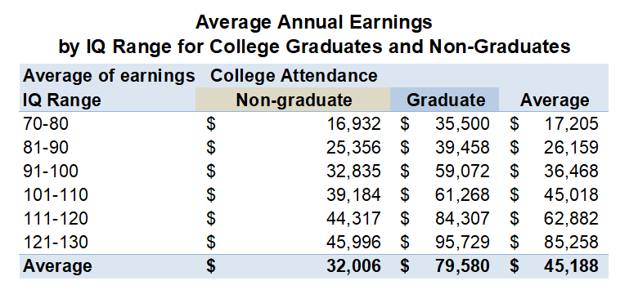

The above graph displays further benefits of a college degree, as graduates make almost double the earnings of non-graduates in each IQ range. No matter the intelligence you possess, it is difficult to translate that natural intelligence to a successful career without the help of a college degree.

The above graph also displays the advantage graduates are provided, as a far higher frequency of graduates are earning six-figure salaries, while non-graduates are mainly earning between $20,000-$60,000. 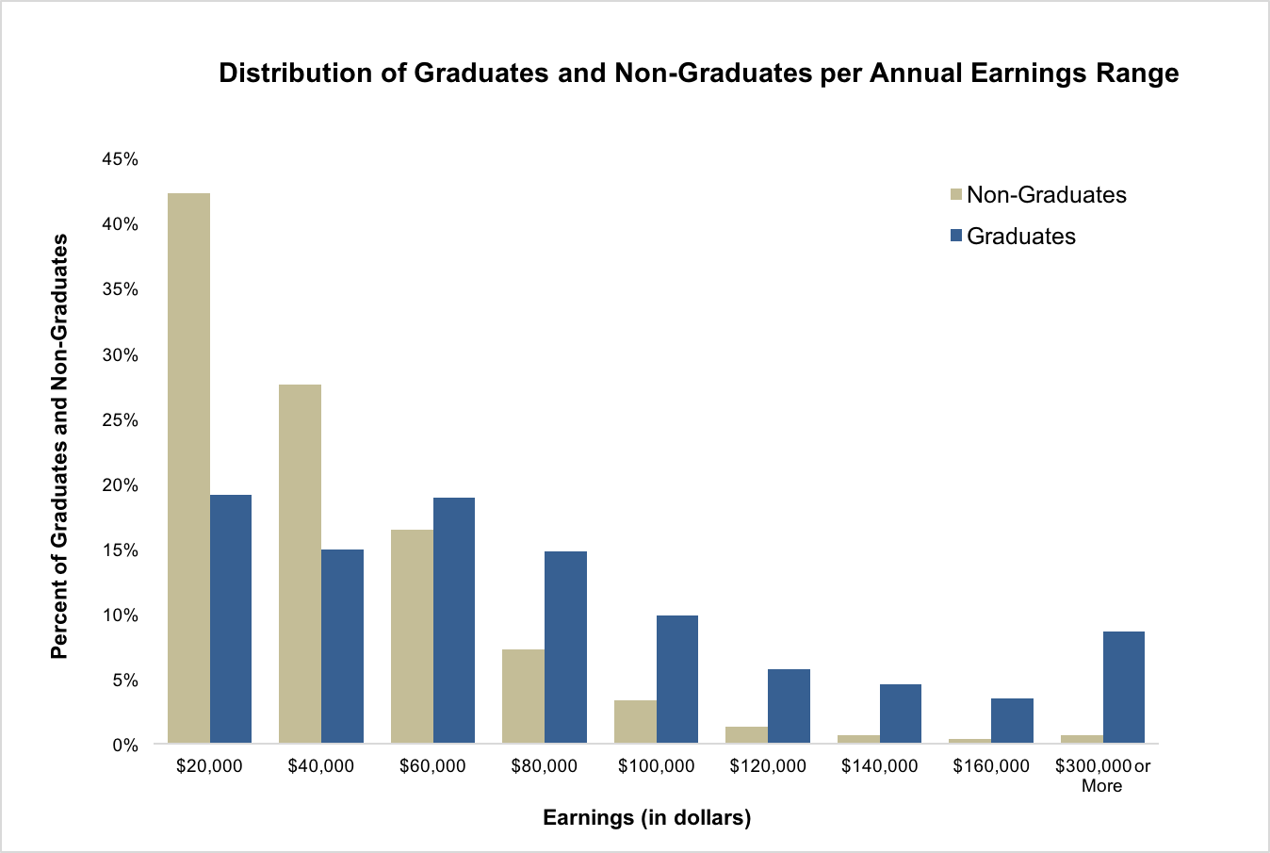

Throughout the four regressions we constructed, the variable college_graduate consistently showed that there is an increase in average earnings related to earning a college degree based on the positive, statistically significant coefficients associated with this variable. We used these coefficients to determine that a college degree is worth the money that it costs, as it provides an advantage to graduates in terms of their future earning potential as well as cognitive ability.

Appendix 1: The Multiple Regression Table

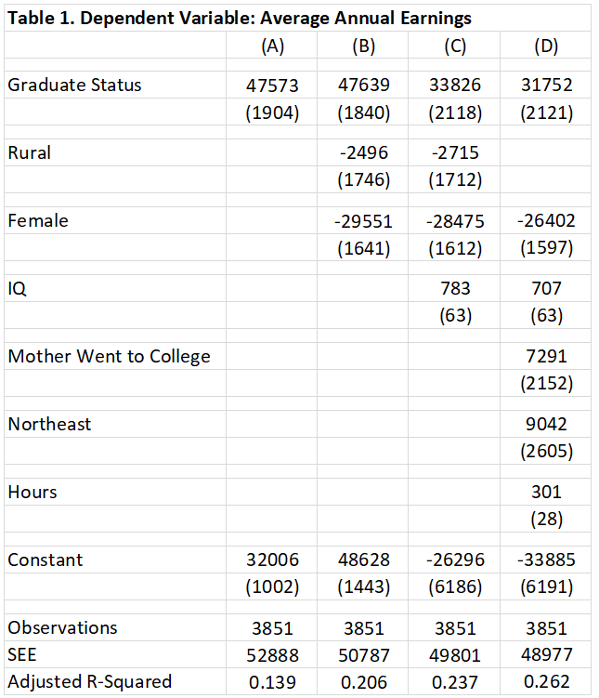

Appendix 2

**Regression A: Earnings based on *college graduate dummy variable***

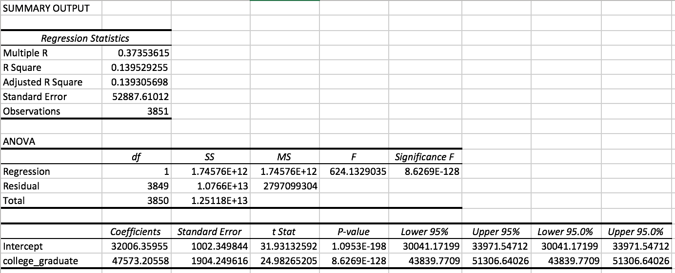

Appendix 3

**Regression B: Earnings based on *rural dummy, gender dummy, & college grad***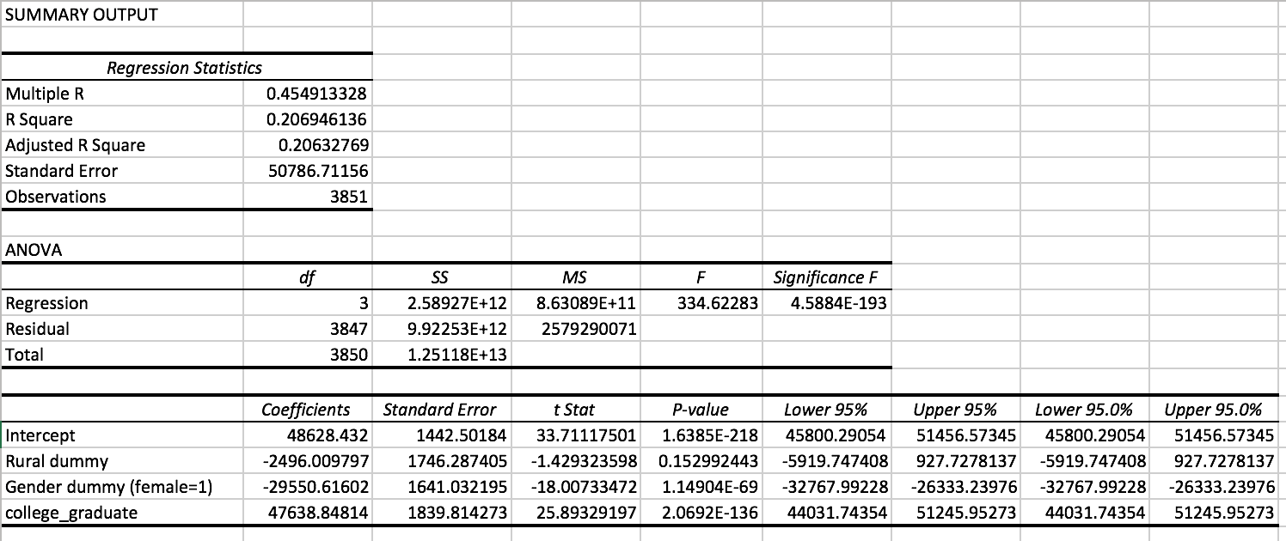

Appendix 4

**Regression C: Earnings based on *IQ, rural dummy, gender dummy and college grad***

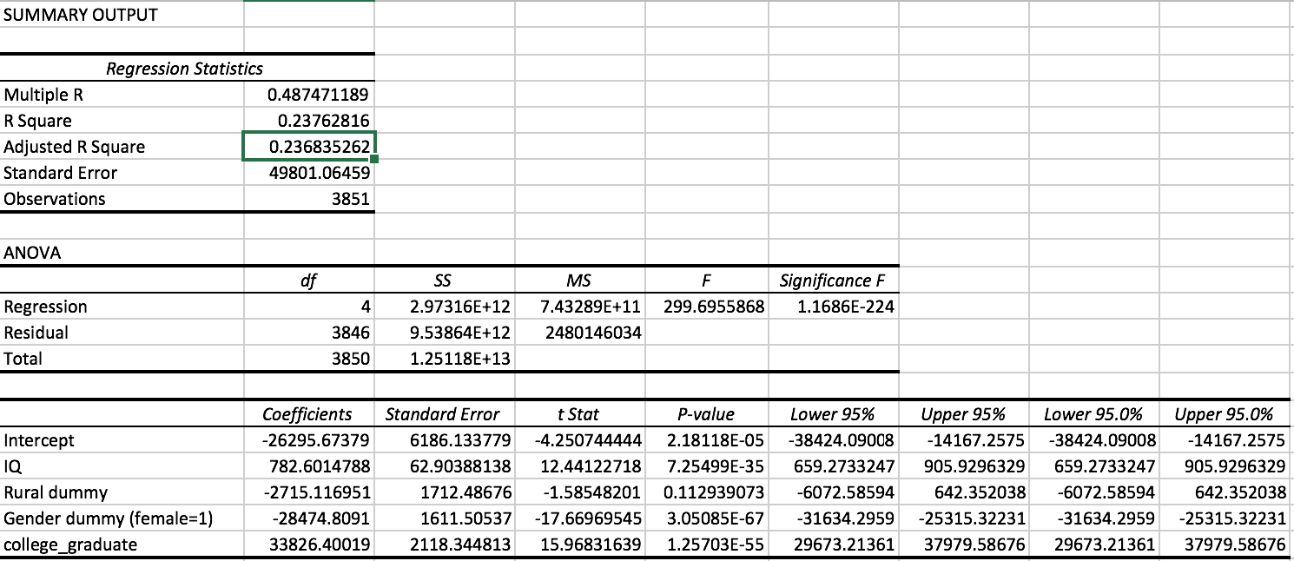

Appendix 5

**Regression D: Our own regression takes IQ, mother’s graduate status, gender, graduate status, and if they live in the Northeast into consideration.**

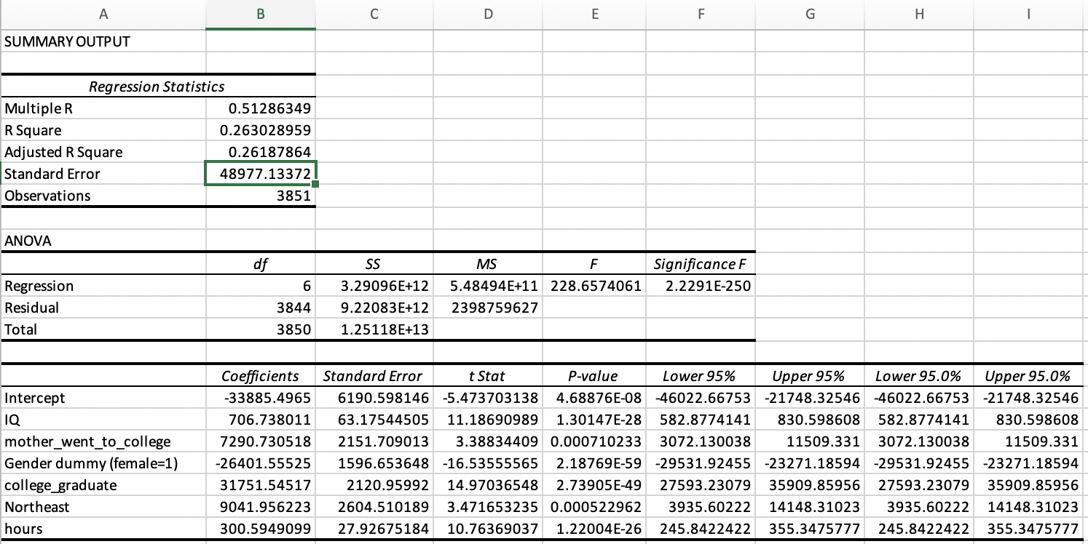

Appendix 6

**Bonus Control Regression:*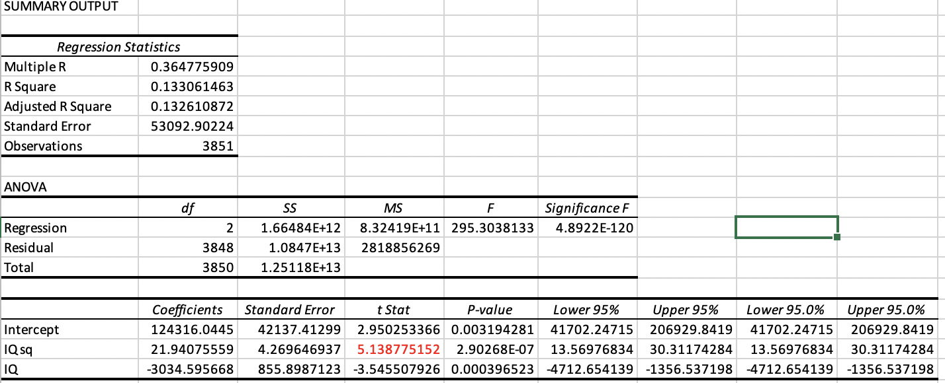***

Appendix 7

**Bonus Complete Regression:**

